https://liveandlethike.com/2015/01/26/panorama-trail-kodachrome-basin-state-park-ut/

Live and Let Hike

An incomplete guide to hiking Utah, Colorado, Virginia, and beyond

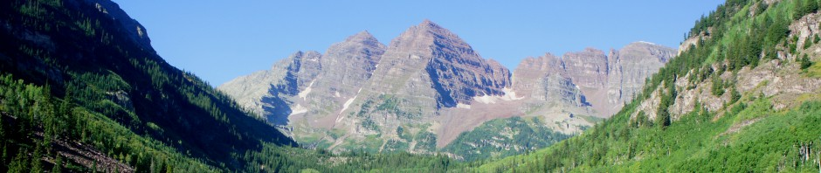

Skip to content
- Home
- About
- Capitol Reef Hiking Guide
- Find A Hike!

← Shinob Canyon (Capitol Reef National Park, UT)
The Motorman (Capitol Reef National Park, UT) →

Panorama Trail (Kodachrome Basin State Park, UT)
Posted on January 26, 2015 by Andrew Wojtanik

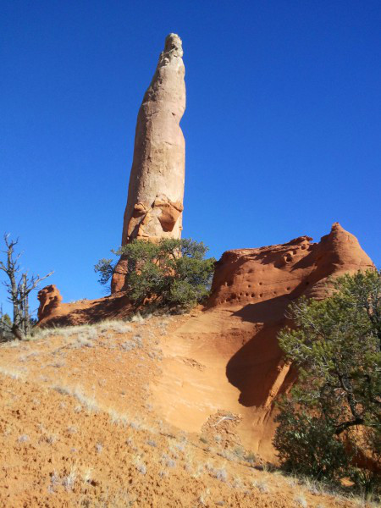
Ballerina Spire, Panorama Trail, Kodachrome Basin State Park, January 2015

At approximately 50-70,000 people per year, visitation at Kodachrome Basin State Park in southern Utah clocks in at just around 3% of its ever-popular neighbor’s up the road—Bryce Canyon—which absorbs nearly two million visitors annually. Though not as striking as Bryce’s dizzying array of pink and orange hoodoos, the unique landscape of spires and box canyons at Kodachrome is arguably more diverse; seeing the park’s multitude of main attractions can easily consume a full day. For hikers, the park’s 5- to 6-mile Panorama Trail loop comprises the “crown jewels,” packing in more points of interest than any other hike in the park. Stops along the mostly flat or gradually-sloping trail include several towering, white-capped spires called “geysers”; the mysterious Secret Passage and Cool Cave; and sweeping views at Panorama Point. A shorter, 3-mile loop is also possible—but skips a number of interesting sights on the outskirts of the route. Allot about a half-day to explore all the different vantage points along the way.
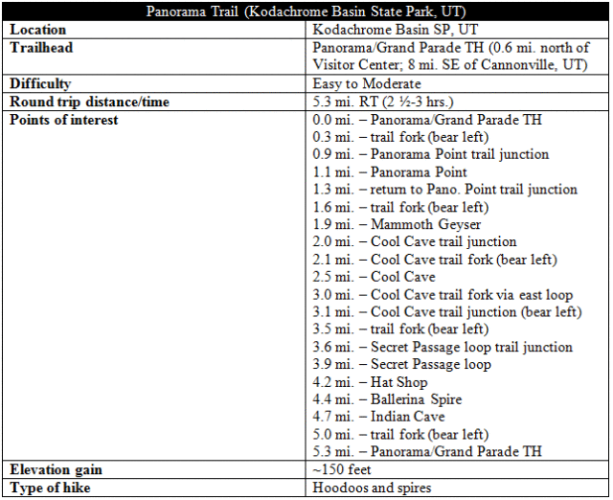

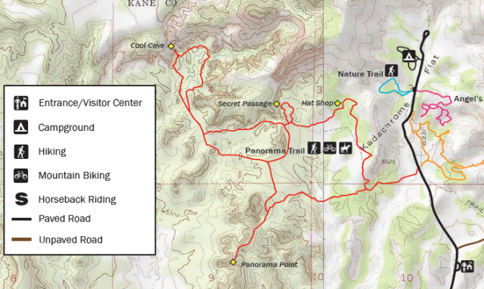
Map of Panorama Trail, clipped from official “Kodachrome Basin State Park Map and Guide”, http://static.stateparks.utah.gov/docs/kbspNewsBrochure.pdf

The hike
(Note: The official Kodachrome Basin literature lists the Panorama Trail as being a 6-mile loop. It feels like—and is, in all likelihood—a bit less. The distances listed above are my best estimates, producing a total of around 5.3 miles.)
The Panorama Trail begins and ends at the designated parking area on the east side of the road about 0.6 miles north of the Kodachrome Basin Visitor Center. This is also the parking lot for the 1.5-mile Grand Parade Trail, which veers off into the jungle of rocks to the east. For the Panorama Trail, park here then cross the street to the west side, where a wayside sign marks the beginning of the hike.
Almost immediately, the wide and sandy trail winds and drops into a rather nasty cut bank. Once on the other side, the trail levels out, climbing only very gradually as it heads west across a flat plain dotted by sagebrush and the occasional juniper. The path is so wide and well-worn that it could almost be classified as wheelchair-accessible—were it not for the ubiquitous sand that would make wheeling a tough slog. After about ¼ mile, the trail climbs perhaps 25 feet over a small ridge where the first group of three tall spires—you will encounter several dozen along the trail—appear on the right. (The closest is called the “Fred Flintstone Spire”.) These pinnacles are composed of reddish-orange Entrada sandstone, the dominant rock layer of Kodachrome Basin (as well as that of the more-famous Arches National Park).

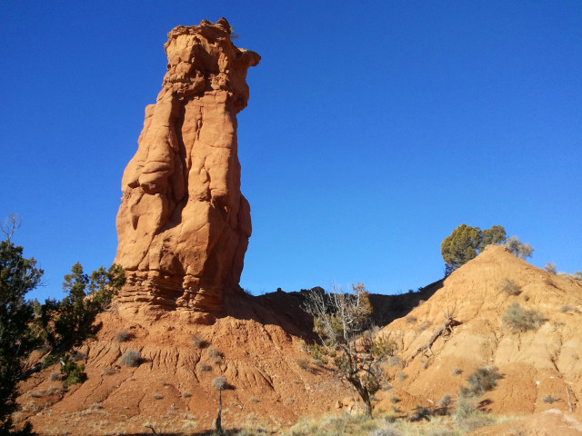
Fred Flintstone Spire near the start of the Panorama Trail, Kodachrome Basin State Park

After cresting the short ridge, the trail forks for the first time, marking the beginning of a large loop. Here decisions must be made based on light: if hiking in the morning to early afternoon, I would recommend going left and following the loop clockwise back to this point, as views to the west from Panorama Point up ahead will be best with the sun at your back; if hiking in the late afternoon, turn right and complete the circle in a counterclockwise direction—maximizing the light shining on the west-facing cliffs the best you can. (The route description here follows the loop in a clockwise direction.)
Bearing left at the trail fork, the Panorama Trail traverses two dry wash beds as it heads toard two large Entrada buttes. Living biological soil crust—also known as cryptobiotic soil—flourishes along the gentle slopes between the two cut banks. A little over a half-mile from the first trail fork, the route diverges again. Take a left at the marked sign for the short detour to Panorama Point.
The 0.2-mile spur trail to Panorama Point weaves between the two large buttes and reveals a third ahead. The path climbs about 100 feet up the latter; a sign (dismantled when I was there) marks that you have reached Panorama Point.

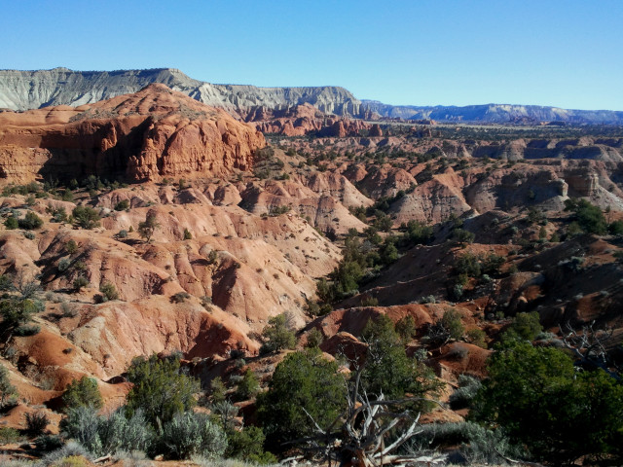
View east from Panorama Point, overlooking Kodachrome Basin State Park and whitish-pink badlands of the Carmel formation

Aptly named, the overlook offers vistas in all directions, with only a small sliver of the horizon blocked by another hillside to the south. In the distance off to the west, notice the thin white-to-pink line of cliffs; this is Bryce Canyon National Park. To the north, you can trace much of the terrain covered by the Panorama Trail, including a conspicuous, white pinnacle known as Mammoth Geyser. Beyond, the Grey Cliffs tower 800 feet over the basin. A look to the east reveals a hillside of faded pink badlands composed of the Winsor Member of the Carmel Formation. To the south, the broad expanse of the 1.9 million-acre Grand Staircase-Escalante National Monument, a maze of sweeping cliffs and deep canyons that is a hiker’s dream.

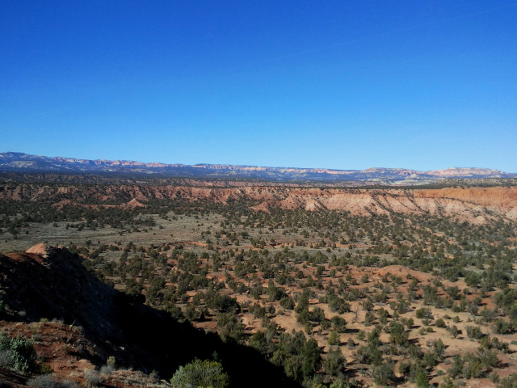
The pink cliffs of Bryce Canyon National Park, viewed from Panorama Point

From Panorama Point, return the 0.2 miles downhill to the trail junction; turn left, heading north. The route is mostly flat for 3/10 mile, at which point there is another unmarked fork. Bear left. Within another 1/3 mile, the trail passes to the right of Mammoth Geyser, the tallest and thickest of the “sedimentary pipes” encountered on the hike. There is a short spur trail that leads to the base of the rocky promontory.

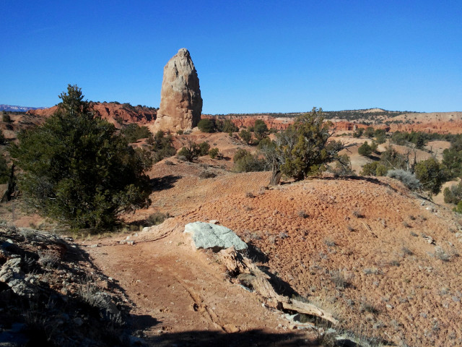
Approaching Mammoth Geyser, Panorama Trail, Kodachrome Basin State Park

Sedimentary pipes differ from the ubiquitous red-orange Entrada spires in the park in that they are thought to be composed of the whitish Paria River Member of the Carmel Formation, a slightly older rock layer that dates to the late Jurassic Period. How did these wily spires form? The details remain a mystery even to geologists, though the prevailing theory suggests that upward pressure forced coarse sediments up through the newer sedimentary layers, forming durable “pipes” that became exposed as the surrounding rock layers eroded away. What caused this pressure remains unknown—some suggest that these hardened protrusions used to be active geysers like those found in Yellowstone…or at least bubbling underwater springs that solidified over time. Mammoth Geyser, true to its name, is one of the park’s tallest—and thickest—sedimentary pipes. (Chimney Rock, accessed from the road to the east, is the tallest, at 170 feet.)

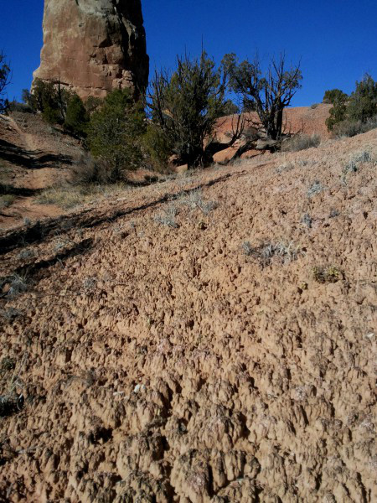
Cryptobiotic soil below Mammoth Geyser

Beyond Mammoth Geyser, it is about 150 yards to the next trail split, located at the base of a line of Entrada sandstone cliffs. Follow the left fork to begin the 1.1-mile lasso loop to Cool Cave. (This loop used to be called the “Big Bear Geyser Trail,” named for one of the spires visible atop the Entrada cliffs to the east.)
Another 150 yards up the trail, the Cool Cave trail splits as it crosses a dry wash. A signpost spirits hikers off to the left—the most direct route to Cool Cave. From here, the left fork makes a beeline for the red-orange cliffs. As the path approaches the Entrada walls, it passes between two tall spires that stand like sentinels guarding the entrance to Cool Cave. The actual turnoff to Cool Cave is 0.1 mile farther; a sign directs hikers to turn left. From here it is about 150-200 yards to the attraction itself.

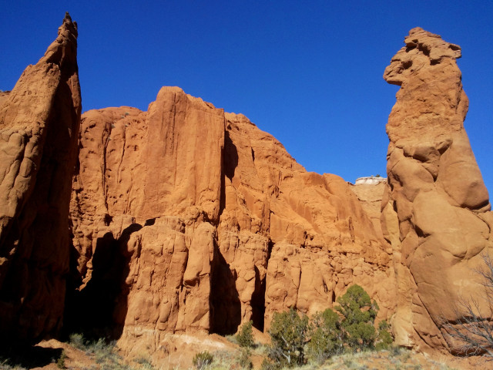
Sentinels standing guard over the entrance to Cool Cave

Cool Cave is more of a cove than a cave and in some ways resembles a classic Utah slot canyon—a narrow traverse between colorfully-lit walls. Follow the muddy wash bottom up and around a bend—the only real obstacle, a 4-foot pouroff, is easily climbed. The mini-canyon ends in a shady alcove; an impassible dryfall rising above is sure to form an impressive waterfall during summer flash floods. Though this is not an enclosed cave, two bubbling globs of sandstone on the left-hand side curiously resemble cavern-like stalagmites. Chilly Cool Cave offers brief but welcome solace on a hot summer day.

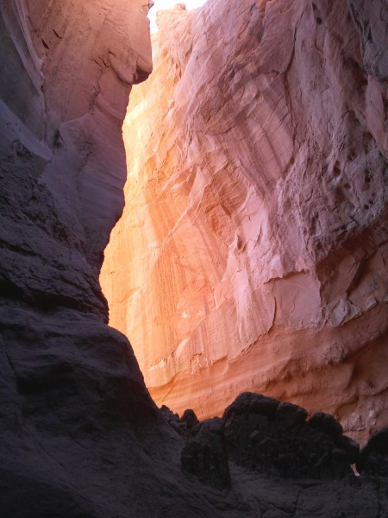
Cool Cave, Panorama Trail, Kodachrome Basin State Park

Upon exiting Cool Cave, turn left at the “Cool Cave–>” sign to continue the 1.1-mile loop. The trail follows the craggy sandstone cliffs for a half-mile, passing a number of tempting side canyons along the way. Near the end of the loop, a tiny rock arch is visible near the top of the 300-foot cliffs. From here it is about 0.2 miles back to the point where the Cool Cave loop splits and another 0.1 miles to the main Panorama loop.

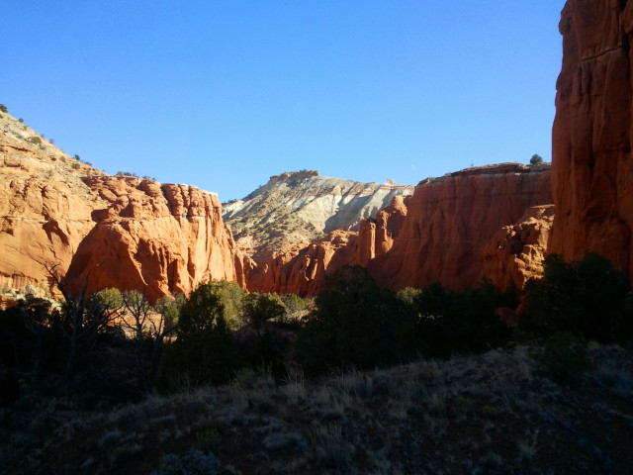
Side canyon along the Cool Cave/Big Bear Geyser Loop

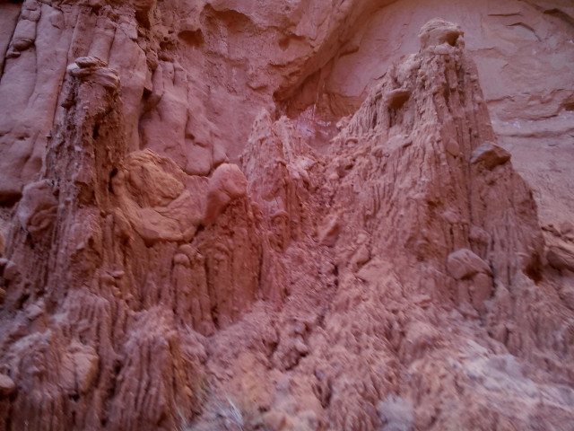
Peculiar crags found in a side canyon off the Cool Cave loop

Turn left at the trail fork. Though the trail sign is unhelpful in that it points in all directions except left, the route is wide and well-worn as usual as it skirts the south-facing cliffs. After about 4/10 mile, the trail traverses a wash enclosed by brown, deeply-grooved badlands that offers a strange but refreshing contrast with the mostly flat, sagebrush-strewn basin. After a short climb, the trail forks yet again—bear left. A minute’s walk leads to another sign, this one marking the start of a 0.3-mile spur loop to the “Secret Passage.”

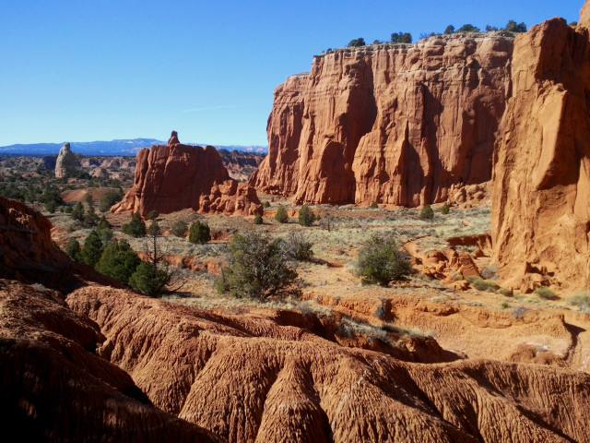
Views from the Panorama Trail, above the weathered badlands

It’s not entirely clear what the “Secret Passage” is, but my best guess is the spot where the trail climbs up and over a small slickrock divide between the high cliffs and a collection of oddball, teepee-looking rocks. These photogenic spires (which I suppose also look like massive anthills) are composed of smooth sloping in the Gunsight Butte Member of the Entrada formation.

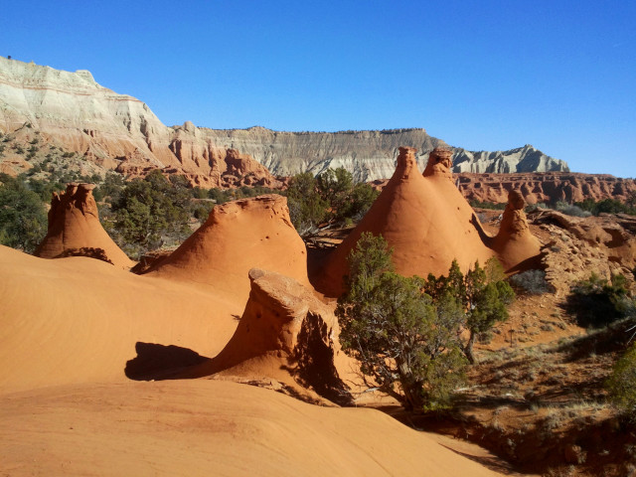
Odd tee-pee-like formations at the “Secret Passage,” Panorama Trail, Kodachrome Basin State Park

The spur loop to Secret Passage is poorly-marked and hard to follow, but basic orienteering will bring one back to the main Panorama loop at the end of the 10-minute detour. A few minutes’ walk down the trail, the route passes directly to the left of a 9-foot spire, one the park’s shortest but easily the most accessible.
The next marked destination is the “Hat Shop,” a collection of peculiar hoodoos, at least one of which looks like it is topped by a ball cap. The viewpoint offers a nice look as well of the steep white cliffs above, composed primarily of the Escalante Member of the Entrada and capped by strips of newer Henrieville and Dakota sandstone.

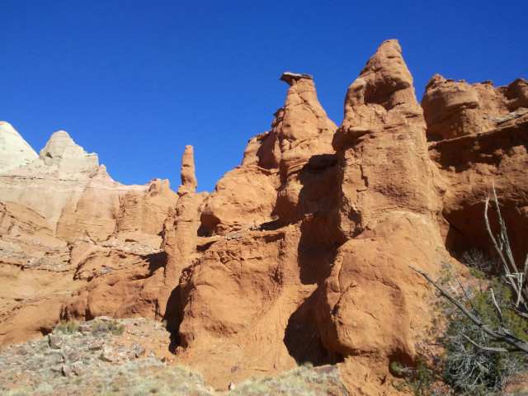
The “Hat Shop,” Panorama Trail, Kodachrome Basin State Park

Just beyond the Hat Shop is Ballerina Spire, certainly one of the highlights of the hike. The gray, narrow pipe reaches high into the sky, dwarfing all other rocks and trees around. Here it is easy to posit a whimsical story of a gushing geyser 70 feet high, suddenly and instantly turned to stone.

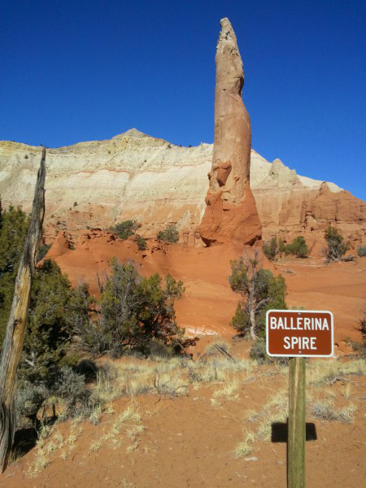
Ballerina Spire, Panorama Trail, Kodachrome Basin State Park

On a number of occasions in this area, the trail crosses an old jeep route; trail markers and visible barriers (i.e., logs placed by trail workers to bar access) mark the way. One such diversion leads hikers to a curious alcove named “Indian Cave,” where someone or something has left thick impressions in the rock that resemble large handprints. This peculiar spectacle is another of Kodachrome’s many mysteries…

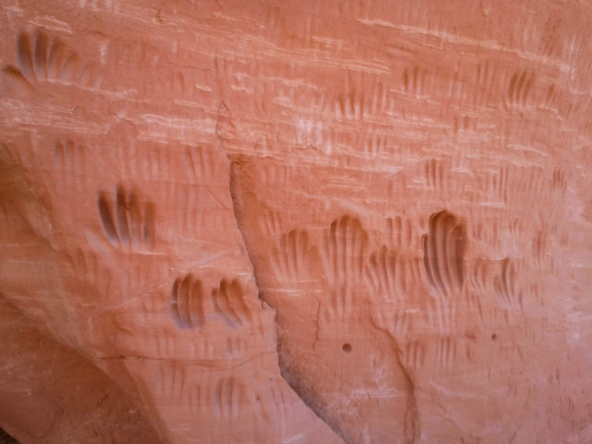
Handprints or peculiar geological weathering? Indian Cave, Panorama Trail, Kodachrome Basin State Park

From this spot, it is a little over ¼ mile to the final trail junction, where a left turn brings one back down the original ridge from the beginning of the hike. Before you know it, you are back at the trailhead, completing the 5.3-mile loop hike through some of Kodachrome’s most interesting territory. Allot at least 2 ½ miles for this interesting hike, or more for the photography- or exploration-minded.

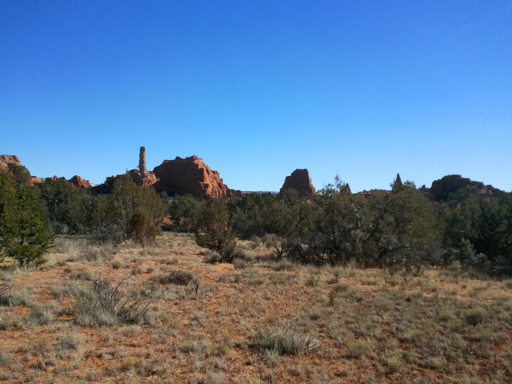
View of a collection of spires south of Panorama Trail, near the trailhead

Share this:

